CO2 emissions

In this report we want to answer three questions. The data we are using to answer these questions comes from the website ourworldindata.org. The questions we want to answer are the following:

1. What is the biggest predictor of a large CO2 output per capita of a country?
2. Which countries are making the biggest strides in decreasing CO2 output?
3. Which non-fossil fuel energy technology will have the best price in the future?

To answer these questions we took some of the datasets from ourworldindata.org, made a selection from this data and made some calculations and graphs which will be explained later on.

**Our first question is; What is the biggest predictor of a large CO2 output per capita of a country?**

The answer to this question is quite simple, it’s wealth. As people get more money and prosperity they will buy more things like home appliances, cars and electronics. Of course this will also put more weight on the environment. We calculated this by using the Pearson correlation coefficient on the GDP per capita and the CO2 emission per capita. This shows us that the correlation is 0.667 which is strong.

Making, using and disposing all of these things is creating CO2 emissions. However at a certain level of wealth, the emissions no longer rise as we can see on the left side of the chart below. As we didn’t have the GDP per capita we calculated this by dividing the GDP of a country by the population of a country. We can see that around a GDP of approximately $5400 ( marked by the dotted line) the CO2 emissions start to stabilize and even slightly decline. This is not because we use less energy but because we can afford less environmental heavy and more energy efficient things. If we zoom in we can see on the right chart that the total energy use, which is measured since 1980, is still on the rise together with the GDP while the CO2 emissions stagnated.

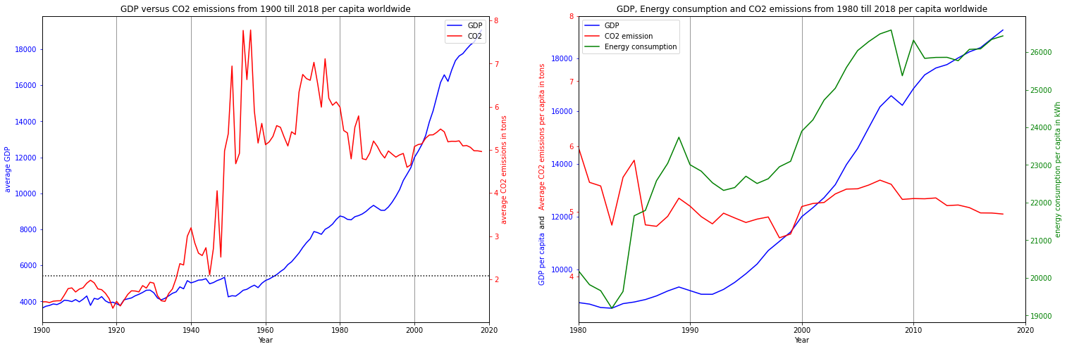

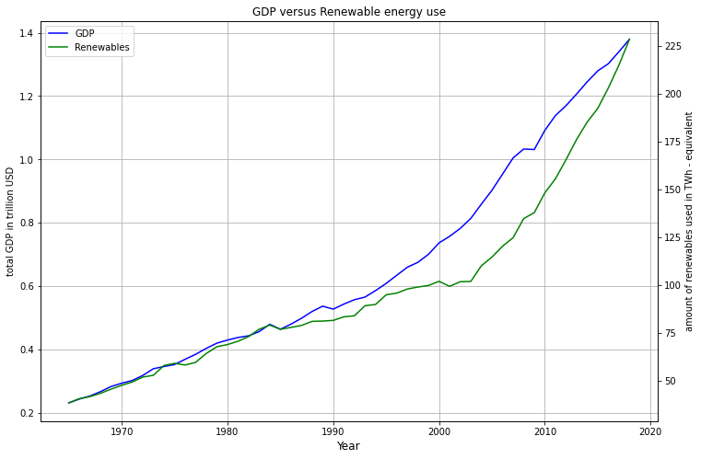Another reason the CO2 emissions stagnate is because of the availability and use of renewable energy. By using the Pearson correlation coefficient to see the relation between GDP and renewable energy use we come a factor 0.808 which is very strong. As we can see in the chart on the right the use of renewable energy and the GDP are going hand in hand.

**The second question we want to answer is; Which countries are making the biggest strides in decreasing CO2 output?**

To calculate this we took a data frame with the population and CO2 emissions per country and per year. To make a fair comparison we took the data from 1990 till 2020 as for many countries the data was missing before that period. This is leaving us with 217 countries. Because the size of the population will have a big influence on the emissions we calculated the relative change in population between 1990 and 2020 as well. We took 4 point for measuring, 1990, 2000, 2010 and 2020. The points in between were used to see if extreme shrinking or growth in population are correct and not caused by incorrect data. We did the same for the CO2 emissions. On average the population growth per country was 163%. Therefore we took out the countries with more than 300% relative growth and less than 70%. This took out 7 countries. Small countries with less than 50k inhabitants are also filtered out (15 countries). For the 190 countries that were left we calculated the relative change and we took the top 10.

As you can see below Moldova has made the biggest stride in CO2 reduction. However they have a relative population change of 92 and the emissions are climbing again despite the shrinking population so the question is how long this will last. As Moldova separated in 1991 from the USSR the question is how the emissions for 1990 were calculated. We can not see any outliers in the dataset for Moldova. Slovakia, Romania, North Korea and Denmark seem to be the countries in the top 10 that are on a steady decline.

Something else worth mentioning is that most of these countries have a relative growth since 1990 below 100. Meaning that the population is shrinking. Exceptions are Denmark, North Korea and Slovakia.

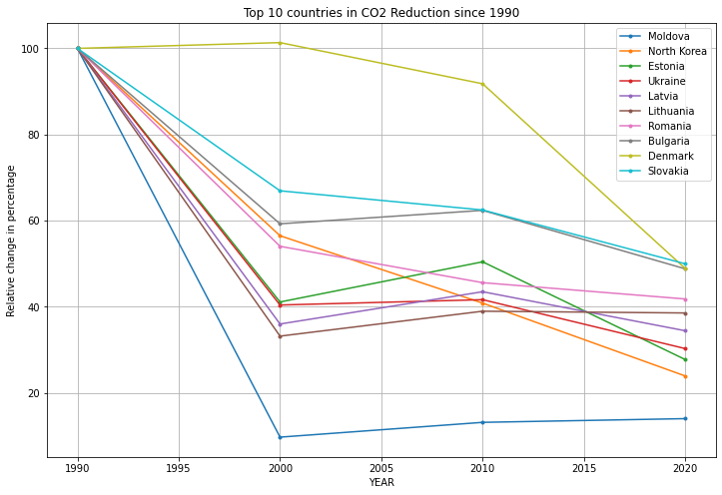

**The last question we want to answer is; Which non-fossil fuel energy technology will have the best price in the future?**

Since our data sets contained only a few countries we took the world total for these calculations. Meaning that these prices are not the actual prices being paid in a country. As the prices for the different energy sources are all calculated in the same way we can still make a fair comparison. If we look at the chart below we can see the various energy sources and their prices.

We can see that price of solar energy has made a huge drop and is still declining. Also the price of onshore wind energy is declining. The price of geothermal, hydro and biomass energy and seem to be stabilizing or slightly rising.

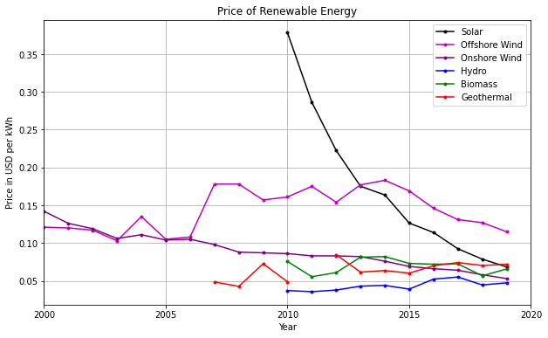

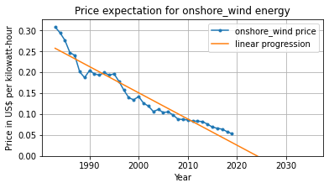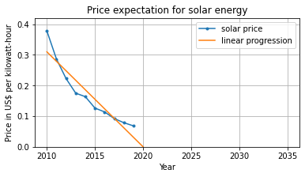If we add a linear progression line on the various energy prices we clearly see that the best prices will be for onshore wind and solar energy. Of course the price can’t go below zero but it’s clear that these 2 energy sources will be performing the best in the future.